Accounts Receivable Training Documentation

for

COLUMBUS COMPUTER REPAIR

Prepared by James Orcutt

Revision 1.0

December 6, 2011

1. Overview and use of document layout.

This is the date the order is to be paid by .

Number of invoice corresponding with database.

This is the dollar amount of the invoice.

This is the date the order was entered.

This field will read “Current” if the “Due Date” has not passed already. If it has, the field will read “Past Due” and will need to be paid and reconciled as soon as possible.

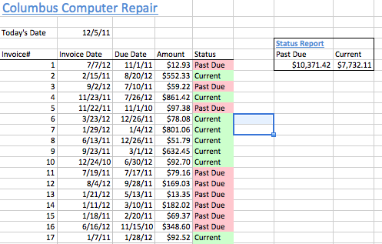

This is the total dollar amount of all the invoices that have been paid by their due dates.

This is the total dollar amount of all the invoices that have not been paid by their due dates.

Accounts Payable

Training Documentation

for

COLUMBUS COMPUTER REPAIR

Prepared by James Orcutt

Revision 1.0

December 6, 2011

1. Overview and use of document layout.

8. Total dollar amount of “Delay” invoices.

7. Total dollar amount of “Past Due” invoices. invoices.

6. Total dollar amount of “Paid” invoices appears here.

2. Due date of invoice to be paid entered here.

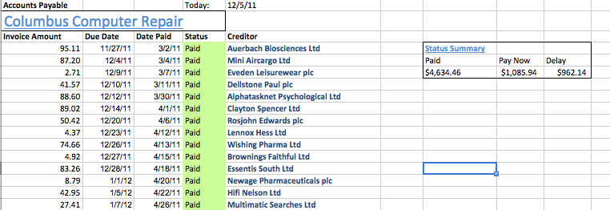

3. The date the invoice was paid will be entered here. If it has not been paid yet, this field will be blank.

1. All invoice dollar amounts are entered in this column.

4. If the date in the “Date Due” column has not passed and the “Status” field for the corresponding invoice is blank, the Status will be “Delay”. If the date has passed, the Status will read “Passed Due” If a date has been entered in the “Date Paid” field then the Status will read “Paid”.

5. The name of the creditor is to be entered here.